DETECTING AI GENERATED IMAGES WITH CNN AND INTERPRETATION USING EXPLAINABLE AI
Design and Implementation
Department of Computer Science and Engineering, [COLLEGE NAME]
Batch C14 (CSE-C) · Academic year [ACADEMIC YEAR]
Table 1: Project team
S.No. | Student name | Roll number
1 | Ponugoti Viduranandan | 23K91A05J5
2 | Naina Baherji | 23K91A05G9
3 | Likki Pranathi | 23K91A05D2
4 | Motasani Sathish | 23K91A05G0

Project guide: M Thanmayee
Chapter and section numbers quoted in the text (for example Chapter 8 or Section 6.2) refer to the full project report, 17.Final Document. Figures and tables in this document are numbered from 1.

1. DESIGN
This chapter turns the requirements of Chapter 4 into a design. It gives the architecture, the workflow of one analysis, the data flow diagrams, the UML models, the data model, the module design, the design of the core algorithm, the interface design and the reasons for the main decisions. Every diagram was drawn from the code in the repository (app/, scripts/ and frontend/) and not from a plan; all eleven are listed again, with explanations, in the block-diagram document.

1.1 Design Goals and Architecture
Five goals shaped the design. The first is an explanation with every verdict: a bare label is not credible in a dispute, so each answer carries per-route votes, Grad-CAM heat maps and a robustness check. The second is heterogeneity: four routes that differ in backbone, input size, loss and augmentation are combined, in the spirit of the heterogeneous ensemble and gating of HEDGE [2], so that one route's blind spot can be outvoted. The third is local operation: an uploaded image is decoded in memory, analysed on the machine and discarded, and no external service is called. The fourth is CPU-only operation: the models are small enough to answer in about two seconds on a desktop processor. The fifth is honest degradation: when a checkpoint is missing the API answers 503 and the Status page names the problem instead of guessing.
The architecture has four tiers. The presentation tier is a React single-page application served by Vite on port 5414; it has a landing page, a sign-in page and four workspace pages, and a client module, lib/api.js, that calls the API with fetch and keeps the bearer token. The application tier is a Flask service on port 8414; its routes are split between app/routes.py (classic HTML pages, health and the original JSON predict) and app/api.py (demo sign-in, configuration, insights and analyze). The inference tier is PyTorch: app/inference.py loads the four models once and runs them, app/ensemble.py fuses the logits, and app/explainability.py and app/robustness.py produce the Grad-CAM overlays and the degraded variants. The data tier is a set of local files: four checkpoints, one metadata file, the evaluation artifacts and the dataset folders.
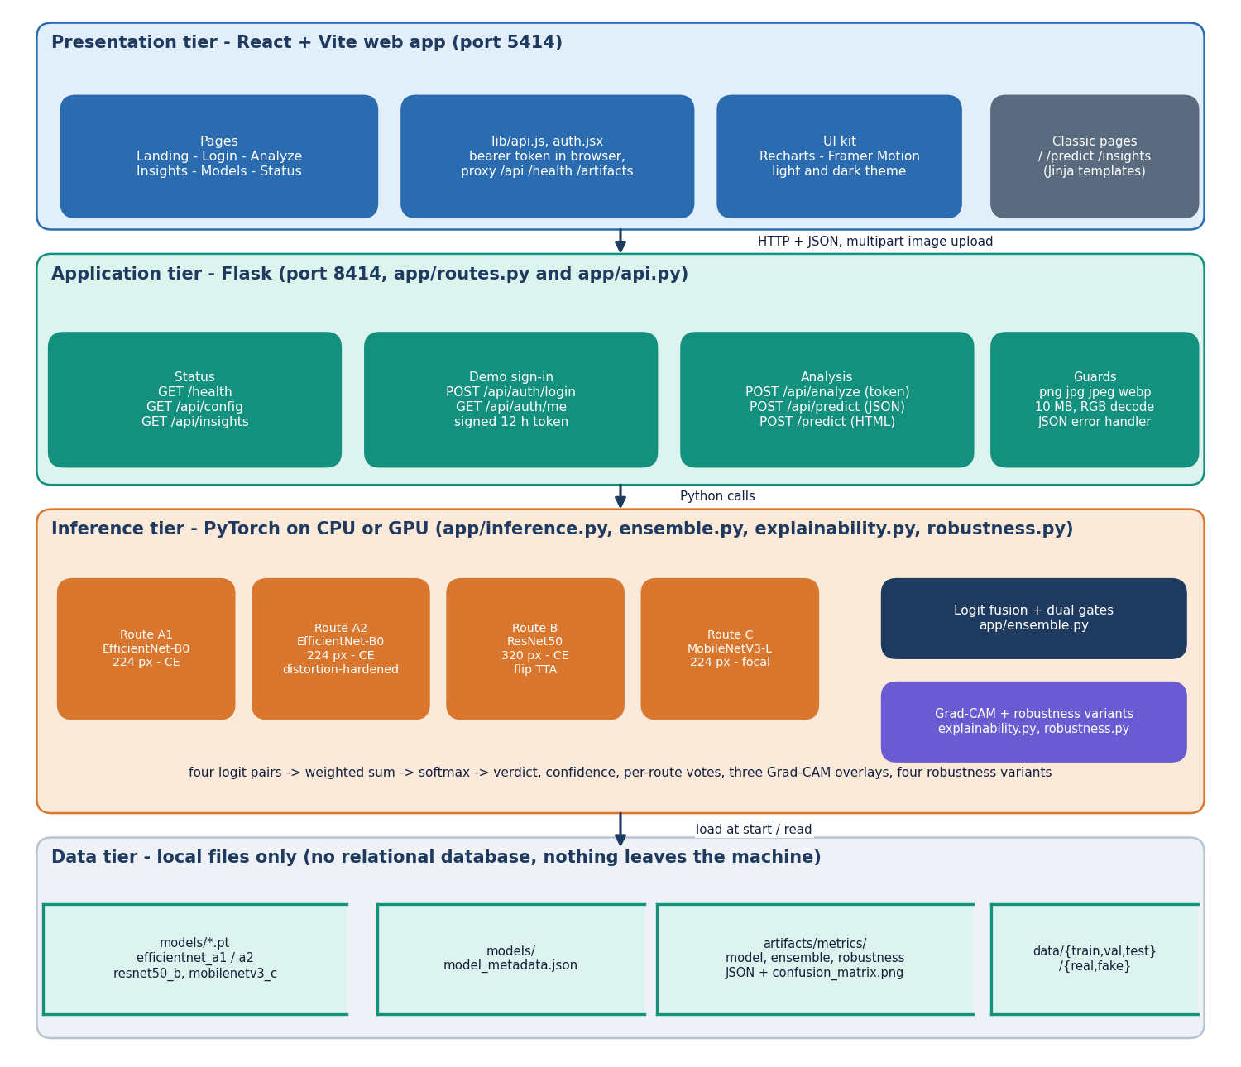
Figure 1: Four-tier architecture of VeriVision AI: React web app, Flask application, PyTorch inference and local file storage.
Table 2: Tiers, technologies and responsibilities
Tier | Technology | Responsibility
Presentation | React, React Router, Vite, Recharts, Framer Motion | Pages, upload form, verdict card, heat-map selector, charts, light and dark theme
Application | Flask 3.1 blueprints, itsdangerous signed tokens | Routes, upload guards, demo sign-in, JSON error handler (400, 401, 413, 500, 503)
Inference | PyTorch 2.14, torchvision, pytorch-grad-cam, OpenCV, Pillow | Preprocessing, four route models, logit fusion with gates, Grad-CAM, robustness variants
Data | Checkpoint .pt files, JSON, PNG, image folders | Model weights, model metadata, evaluation artifacts, train / validation / test images

The inference modules are plain Python files of functions, not a class hierarchy. Each stage takes data and returns a dictionary, so it can be tested on its own, replaced without touching the others, and the whole analysis can be returned as one JSON object. The UML diagram in Section 5.4 draws these modules as classes only to show their responsibilities. The classic server-rendered pages of the first version remain available on the API port as a fallback.

1.2 High-Level Workflow
The workflow of the system is the workflow of one POST /api/analyze request, and it has ten stages. The image is validated (extension, size, non-empty, decodable) and converted to RGB. It is resized for each route and normalised with ImageNet statistics. The four routes return a pair of logits each, Route B averaging the original and a horizontally flipped copy. The pairs are fused with the configured weights and two gates into a verdict, a probability pair and a confidence word. Grad-CAM overlays are produced for three routes on the predicted class. The image is then re-tested under JPEG compression, a half-size resample and a Gaussian blur, and the number of variants that keep the original verdict is reported. The result is returned as one JSON object and displayed as a verdict card with tabs.
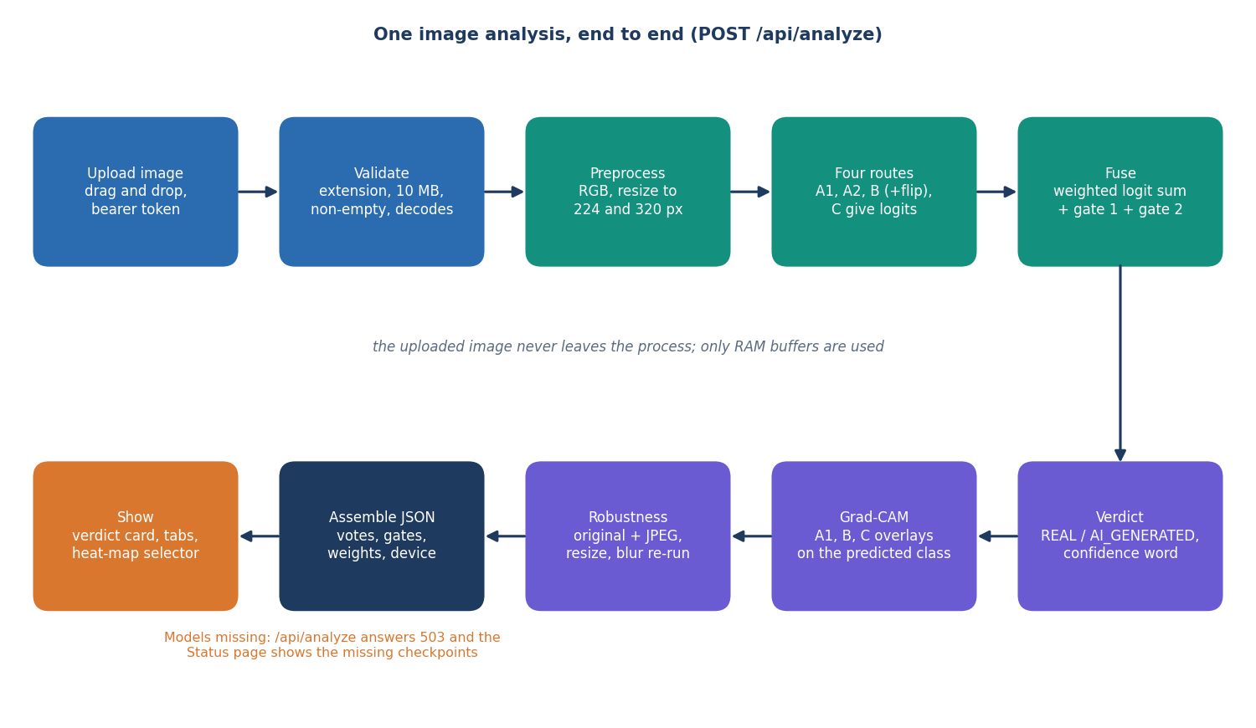
Figure 2: High-level workflow of VeriVision AI for one POST /api/analyze request.
There is one failure path that matters. If a checkpoint file is missing, ensure_models_loaded raises an error that lists the missing files, the analyze and predict endpoints answer 503, and /health reports status 'degraded' with the same message, which the Status page shows. If Grad-CAM fails for one route, that overlay is returned as null and the others are unaffected; if the robustness check fails, the consistency is reported as 'n/a'.
A second workflow runs offline and prepares the models. A dataset script builds class-balanced train, validation and test folders; each route is fine-tuned from ImageNet weights with its own augmentation, AdamW with cosine decay and early stopping on the validation F1; and an evaluation script measures every route and the ensemble and writes the JSON artifacts that the Insights page reads (diagram 11 of the block-diagram document).

1.3 Data Flow Diagrams

1.3.1 Level 0: context
At the context level VeriVision AI is one process with two actors and no external service. The user sends an image and the demo login and receives the verdict, the confidence, the per-route votes, the Grad-CAM overlays and the robustness result. The developer sends training and evaluation commands and receives checkpoints and metrics. The process reads and writes the model files and metric artifacts and, in training, reads the image folders.
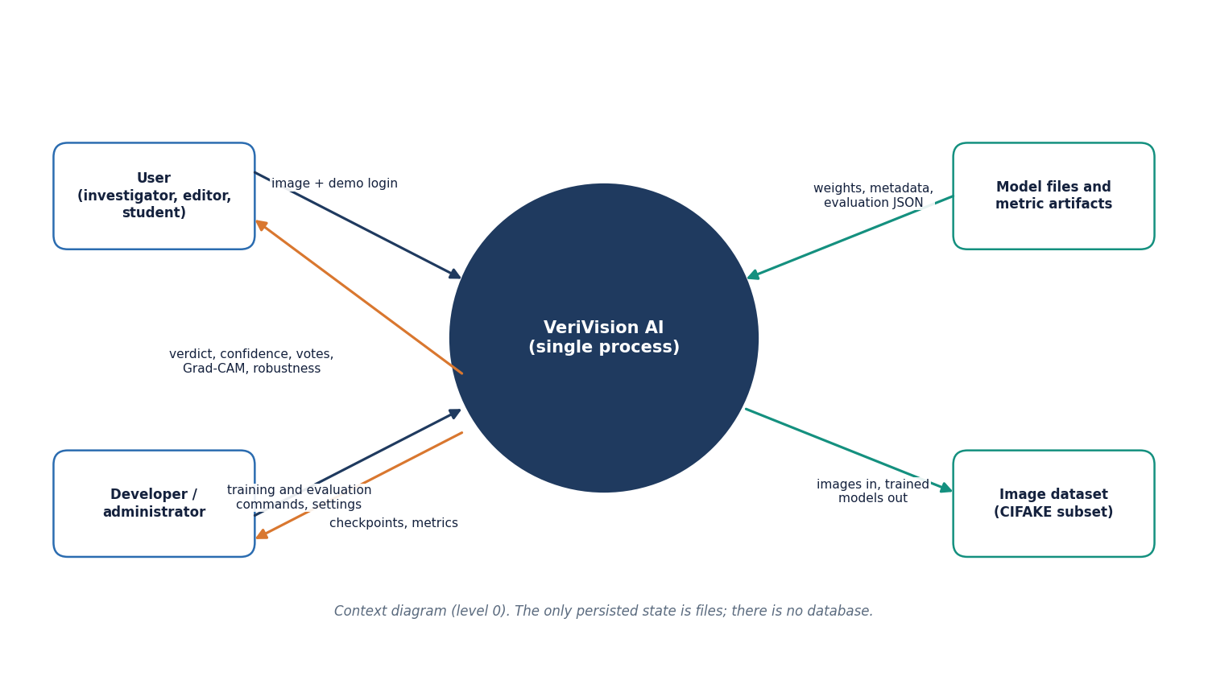
Figure 3: Context diagram (DFD level 0) of VeriVision AI with its two actors and two external stores.

1.3.2 Level 1: main processes
Level 1 divides the system into seven processes over three stores: D1, the model checkpoints; D2, the model metadata; and D3, the metric artifacts. Process 2.0 loads D1 and D2 once, on the first request.
Table 3: Level 1 processes and their data
No. | Process | Inputs | Outputs | Stores
1.0 | Validate and authenticate | Image, demo login, token | RGB image, 400 / 401 / 413 errors | -
2.0 | Preprocess and route logits | RGB image | Four logit pairs | D1, D2 (read)
3.0 | Fuse and gate | Logit pairs, weights, gate settings | Verdict, probabilities, confidence | -
4.0 | Explain (Grad-CAM) | Image, predicted class | Three heat-map overlays | D1 (read)
5.0 | Robustness re-check | Image | Verdicts on JPEG, resize, blur variants | D1 (read)
6.0 | Report insights | Stored metrics | Insights JSON, confusion matrix image | D3 (read)
7.0 | Train and evaluate | Developer commands, image folders | Checkpoints, metadata, metrics | D1, D2, D3 (write)

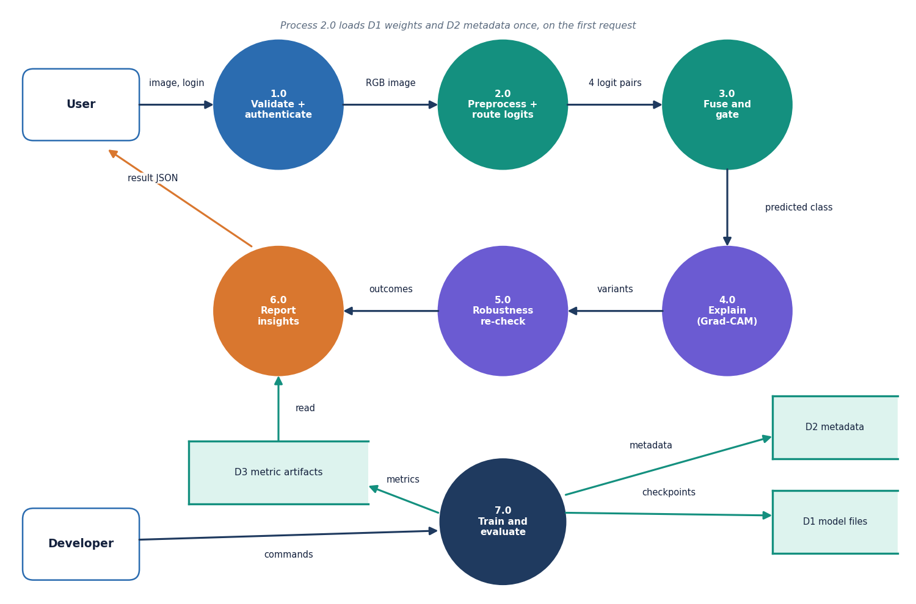
Figure 4: DFD level 1 of VeriVision AI: seven processes and three data stores.

1.3.3 Level 2: preprocessing, route logits and fusion
Level 2 expands processes 2.0 and 3.0 into the steps of app/inference.py and app/ensemble.py.
The sub-processes are: 2.1 decode and resize (preprocessing.decode_image, Resize in inference._transform_for); 2.2 normalise with the ImageNet mean and standard deviation; 2.3a to 2.3d the route logits of A1, A2, B (with the flipped copy) and C (inference.branch_logits, reading D1); 3.1 Gate 1 (ensemble.apply_gate1); 3.2 the weighted logit sum (ensemble.fuse_logits); 3.3 Gate 2 (ensemble.apply_gate2); and 3.4 the softmax and confidence wording (ensemble.softmax, inference.confidence_word).
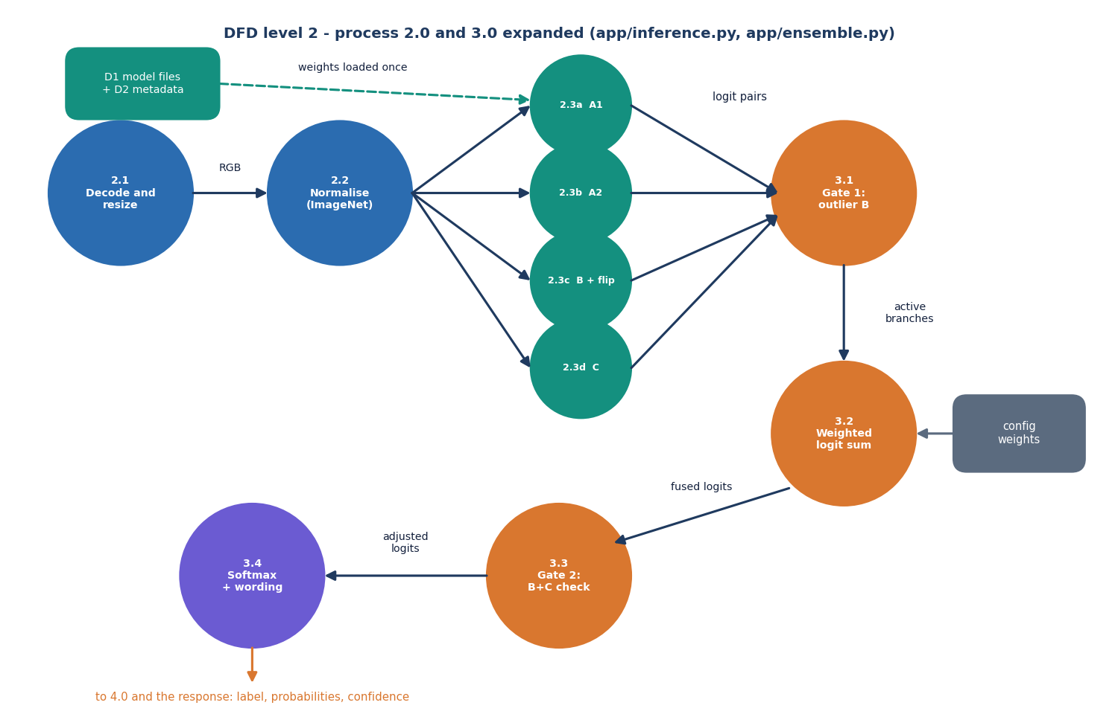
Figure 5: DFD level 2 of VeriVision AI: processes 2.0 and 3.0 expanded into eleven sub-processes.

1.4 UML Diagrams

1.4.1 Class diagram
FlaskApp, the application factory in app/__init__.py, registers two blueprints: Routes (app/routes.py) and Api (app/api.py). The Api blueprint reuses the analysis routine _run_analysis of Routes so that the classic page and the JSON endpoint return identical results. Both call Inference, which uses Preprocessing for validation and decoding, Models for the four architectures and their checkpoints, Ensemble for fusion and gating, Explainability for Grad-CAM and Robustness for the degraded variants. Config holds every tunable setting and can be overridden by environment variables. The training scripts reuse the model builders of Models. The modules are files of functions; they are drawn as classes to show responsibilities.
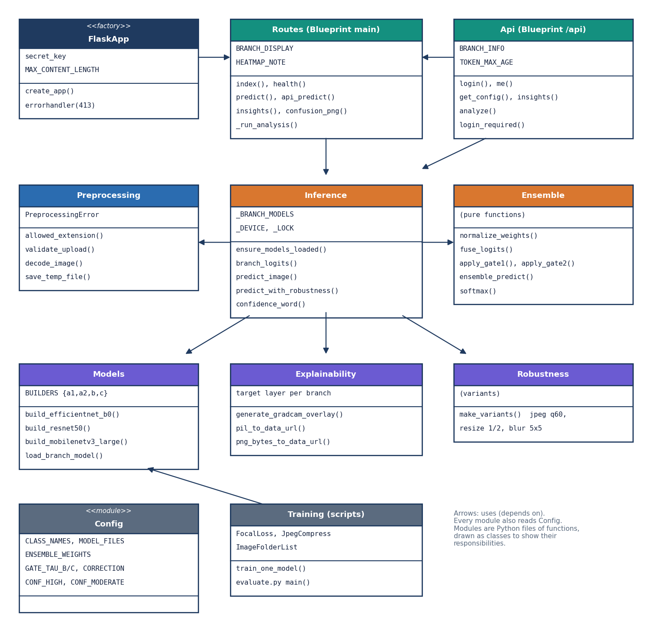
Figure 6: UML class diagram of VeriVision AI showing the application factory, the two blueprints and the service modules.

1.4.2 Sequence diagram
The sequence diagram follows one analysis. The browser posts the image with its bearer token; api.py verifies the token (401 if it is missing, forged or older than twelve hours), makes sure the models are loaded (503 if not), validates and decodes the upload (400 on failure) and calls predict_image. Inference runs the four forward passes and asks Ensemble for the fused result. api.py then asks Explainability for the three overlays and Inference for the robustness check, assembles one dictionary and returns it as JSON.
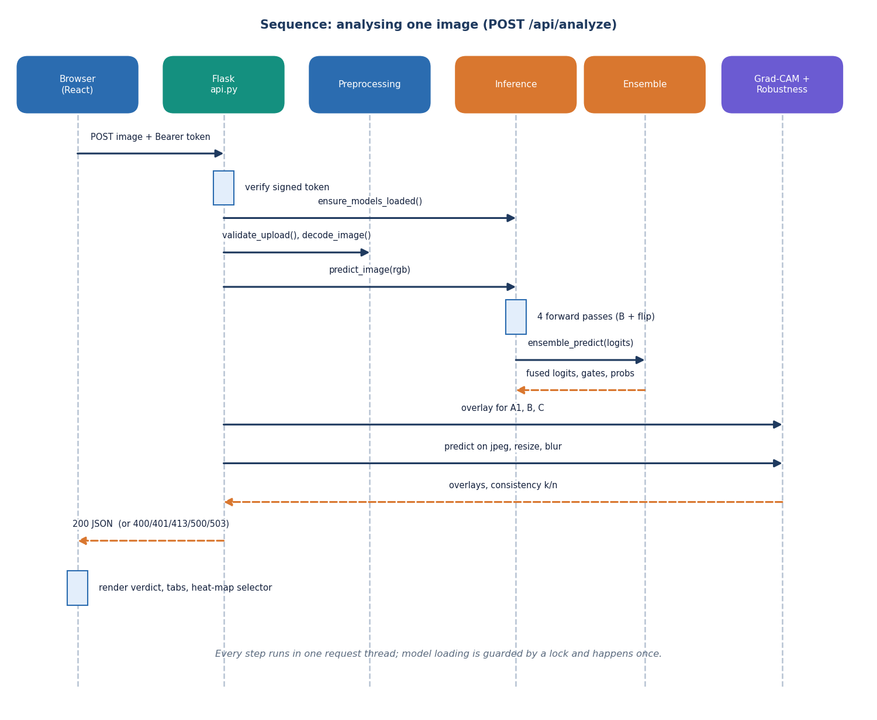
Figure 7: Sequence diagram of one image analysis, from the browser upload to the JSON response.

1.4.3 Use-case diagram
There are two actors. The user signs in with the demo account, uploads an image, reads the verdict and confidence, inspects the per-route votes, opens the Grad-CAM heat map and checks the robustness consistency; the user can also read the model insights and the system status. The developer reads the same insights and status pages and prepares data, trains and evaluates the models with the scripts. The verdict, votes, heat map and robustness all depend on an uploaded image.
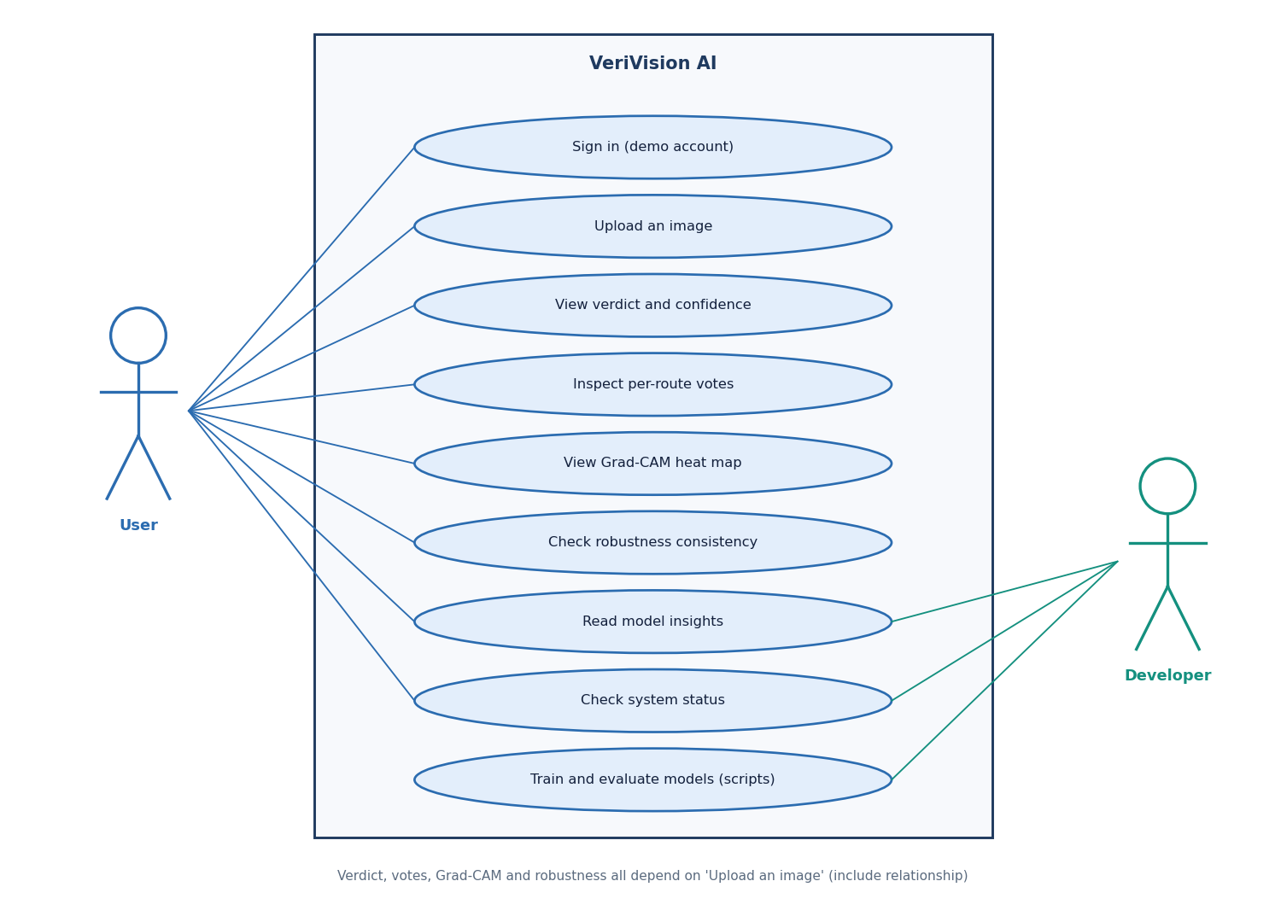
Figure 8: Use-case diagram of VeriVision AI with the user and the developer.

1.5 Data Model and Storage Design
VeriVision AI has no relational database. The system keeps no user accounts (one demo account is configured), no history of analyses and no uploaded images, so a database would add a dependency without adding a capability. Everything that persists is a file, and the entity-relationship diagram below shows those files and their relations. The two entities at the bottom, SessionToken and UploadBuffer, exist only inside a request and are never stored.
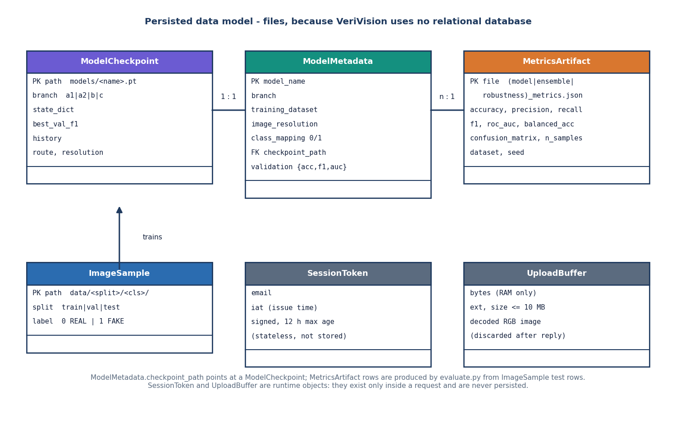
Figure 9: Persisted data model of VeriVision AI: model checkpoints, model metadata and metric artifacts, plus the runtime-only session token and upload buffer.
Table 4: Persisted and runtime data
Entity | Where | Content | Written by | Read by
ModelCheckpoint | models/*.pt | state_dict, best validation F1, training history, route, resolution | scripts/common.train_one_model | models.load_branch_model
ModelMetadata | models/model_metadata.json | model name, branch, training dataset, resolution, class mapping, checkpoint path, scores | scripts/evaluate.py or scripts/publish_cifake_models.py | GET /api/config
MetricsArtifact | artifacts/metrics/ | model, ensemble and robustness JSON; confusion_matrix.png | scripts/evaluate.py or scripts/publish_cifake_models.py | GET /api/insights, /artifacts/confusion_matrix.png
ImageSample | data/train|val|test/real|fake | PNG images; label 0 = REAL, 1 = AI_GENERATED from the folder name | scripts/prepare_*.py | scripts/common.collect_split
SessionToken | browser only | email and issue time, signed, 12 h maximum age | api.login | api.login_required
UploadBuffer | RAM | uploaded bytes and the decoded RGB image | preprocessing | inference, explainability

The class mapping 0 = REAL and 1 = AI_GENERATED is defined once, in app/config.py, and is used by training, inference, Grad-CAM and the interface. The scores stored in the metadata file and the metric files are written from the held-out test evaluation (by evaluate.py, or in this project by publish_cifake_models.py from experiments/cifake/metrics.json, in the same format), so the Insights and How-it-works pages read measured values and never typed ones.

1.6 Module Design
The back end has eleven modules, each with one responsibility. The table lists them with their main functions and line counts, which show that the whole serving code is small enough to be read in one sitting.
Table 5: Back-end modules (app/)
Module | Lines | Responsibility | Main functions
__init__.py | 29 | Application factory; JSON-aware 413 handler | create_app
config.py | 69 | All settings, environment overrides, class mapping, weights, gates | constants
preprocessing.py | 88 | Upload validation and decoding | validate_upload, decode_image, PreprocessingError
models.py | 83 | Architectures and checkpoint loading | build_efficientnet_b0, build_resnet50, build_mobilenetv3_large, load_branch_model
inference.py | 143 | Model cache, route logits, flip TTA, verdict, robustness check | ensure_models_loaded, branch_logits, predict_image, predict_with_robustness
ensemble.py | 129 | Logit fusion and the two gates | fuse_logits, apply_gate1, apply_gate2, ensemble_predict, softmax
explainability.py | 80 | Grad-CAM overlays and data-URL helpers | generate_gradcam_overlay, pil_to_data_url
robustness.py | 34 | JPEG, resize and blur variants | make_variants
routes.py | 197 | Classic pages, health, original JSON predict, shared analysis | health, predict, api_predict, insights, _run_analysis
api.py | 140 | Demo sign-in, config, insights, protected analyze | login, me, get_config, insights, analyze, login_required
run.py | - | Entry point, .env reader, model pre-load, server start | app.run on 127.0.0.1:8414

Around the serving code sit the scripts and the front end. The data scripts (prepare_dataset.py, prepare_cifake.py, prepare_xdomain.py) build the image folders; common.py and train_a1.py, train_a2.py, train_b.py and train_c.py hold the augmentation, the focal loss, the training loop with early stopping and the per-route freezing rules; evaluate.py, run_cifake_experiments.py and measure_latency.py produce the metrics, the ablations, the robustness and cross-domain results and the timings; smoke_test.py and two pytest files check the system. The front end has seven routes (landing, sign-in, four workspace pages and a fallback page) and a lib/ folder with the fetch client, the session, the analysis state and the theme.

1.7 Design of the Core Algorithm
The core algorithm is the fusion of the four route outputs. Each route returns a pair of raw logits. The weights are 0.35 for A1, 0.15 for A2, 0.25 for B and 0.25 for C; they are normalised at run time so that any positive set works. Two deterministic gates operate on the logits and never on probabilities. Gate 1 removes Route B when its margin |l_fake - l_real| is at least 2.5 and all three other routes point to the other class; the remaining weights are renormalised. Gate 2 acts after the weighted sum: when B and C agree on a class with margins of at least 2.5 and 2.5, and the fused direction is the opposite one, the fused logits are nudged toward the B and C class by 0.75, the winning logit rising by that amount and the other falling by half of it. A softmax then gives the probabilities; the larger is the confidence, shown as High at 0.85 or more, Moderate at 0.60 or more and Low below that.
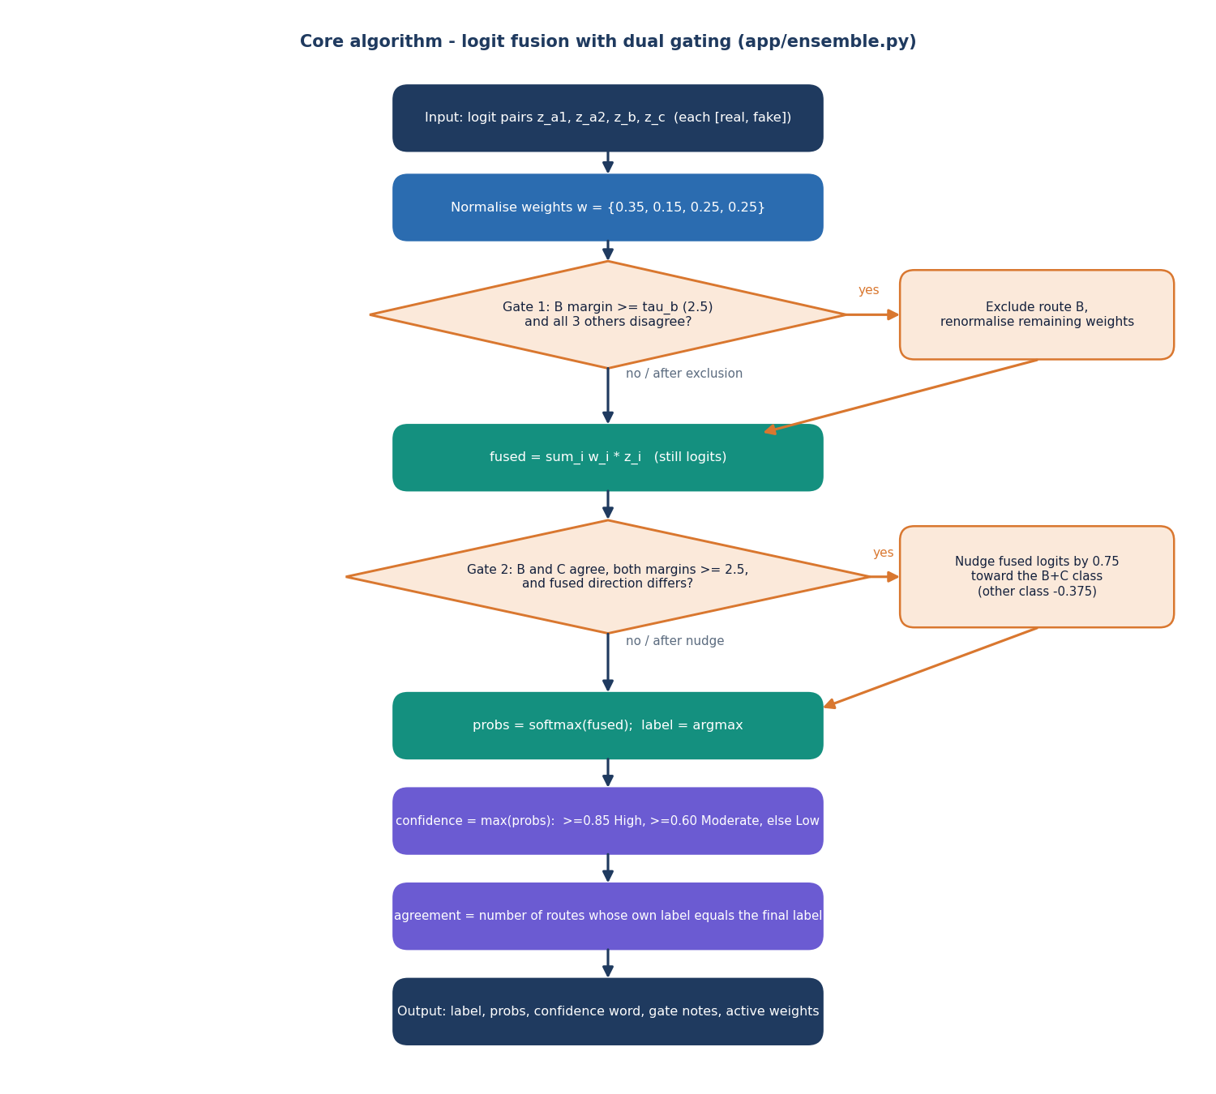
Figure 10: Flowchart of the logit fusion with the two gating rules implemented in app/ensemble.py.
The design deliberately keeps every step visible. The response carries the per-route labels and probabilities, the active weights after Gate 1, a sentence for each gate saying whether it fired and why, and the number of routes that agree with the final label, so that a reader can reconstruct the verdict by hand. The gate values are engineering defaults taken in the spirit of the dual gating in HEDGE [2], not values tuned for this project; Chapter 8 reports that on the held-out test set Gate 1 fired on 7 of 2,000 images and Gate 2 on none.
Explanation follows the same rule. Grad-CAM [26] is computed with the pytorch-grad-cam library [27] on the last convolutional block of the route (features[-1] for A1 and C, layer4[-1] for B), for the class the ensemble predicted, and is blended over the input image. It is offered for three of the four routes: A2 shares its architecture with A1 and was left out to keep the response small. The interface states that a heat map is an explanation aid and not proof of authenticity.

1.8 User Interface Design
The interface is a single-page React application with a fixed side navigation, a status chip showing whether the API is online and on which device it runs, a theme switch and a sign-out button. It was designed around the order of a user's questions: what is the answer, how sure is it, who voted, where did the models look, and how stable is the answer. The Analyze page therefore shows the verdict card first, then the branch votes next to the robustness check, then the Grad-CAM heat maps with one tab per route.
Table 6: Pages of the web application
Page | Route | Purpose | Data source
Landing | / | Introduction, headline measured numbers, how the system works | GET /api/insights, /api/config
Sign in | /login | Demo account sign-in with a button that fills the demo credentials | POST /api/auth/login, GET /api/config
Analyze image | /app | Upload, verdict, votes, Grad-CAM, robustness | POST /api/analyze
Model insights | /app/insights | Held-out metrics, confusion matrix, clean-versus-degraded chart | GET /api/insights
How it works | /app/models | The four routes: backbone, input size, loss, fusion weight, trained-on, validation F1 | GET /api/config
System status | /app/status | Live /health answer: API, models loaded, device; upload rules | GET /health, /api/config

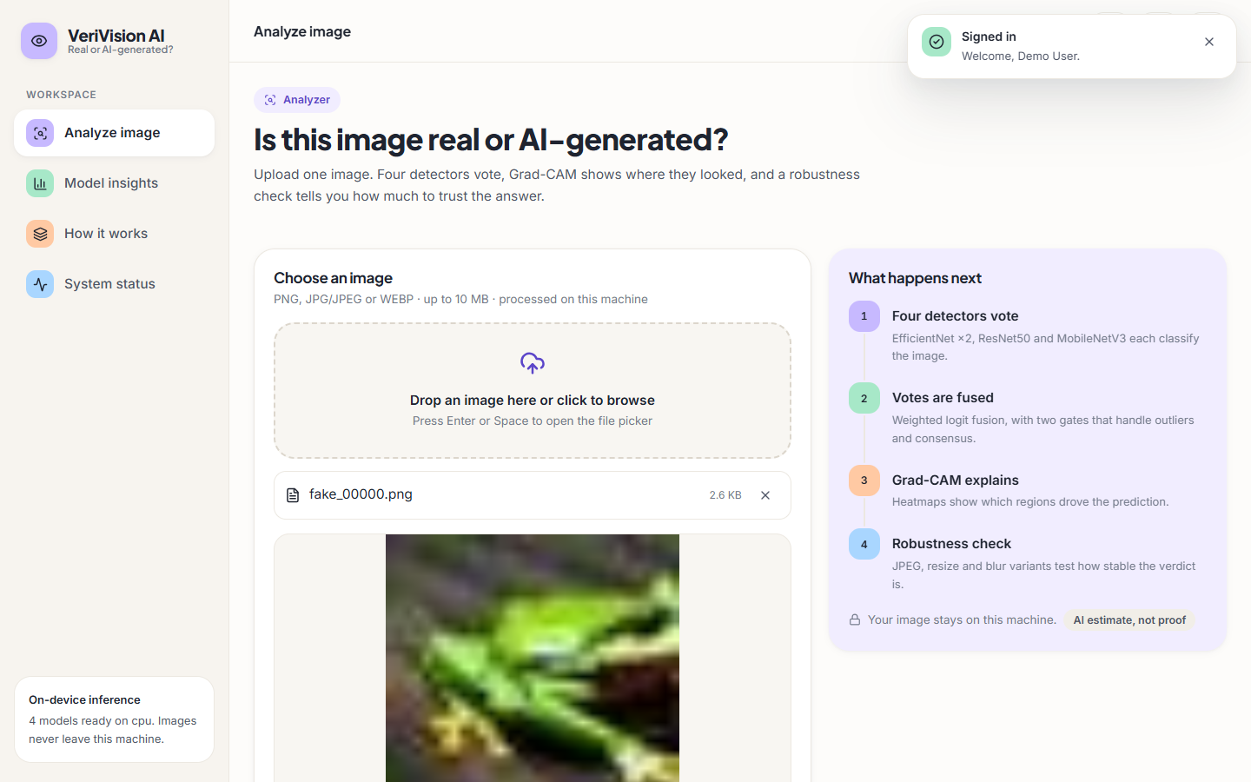  Figure 11: Analyze page with an image chosen and the four steps explained on the right. | 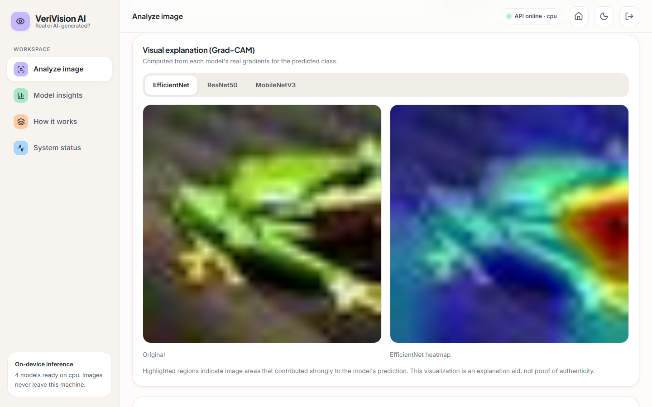  Figure 12: Grad-CAM tab: original image beside the EfficientNet heat map.

Several choices keep the interface honest. Every number on the Insights and How-it-works pages is read from the API and so from the evaluation files. The verdict is worded as 'Likely AI-generated' or 'Likely real', never as a certainty, and the confidence word is shown with the percentage. Errors from the API are shown as readable messages. Light and dark themes are both supported, and the upload area opens the file picker from the keyboard (Enter or Space).

1.9 Design Decisions and Their Reasons
Table 7: Principal design decisions
Decision | Alternative | Reason
Four small CNN routes, ImageNet-pretrained, upper blocks fine-tuned | One large foundation-model detector | Trainable on a CPU in minutes to under an hour per route; large backbones need GPUs (HEDGE used eight H800 cards)
Heterogeneous routes (backbone, size, loss, augmentation) | Four copies of one model | Different inductive biases make errors less correlated; Chapter 8 measures how much this helps
Fusion in logit space | Averaging probabilities, majority vote | Keeps the strength of each route's evidence; Chapter 8 compares all three on the same logits
Two deterministic gates | Learned meta-classifier | No extra training data needed and the rule can be read in the response; the gates did not improve results here
Robustness re-check in the response | Report only the verdict | Social-media compression removes cues; the user sees whether the verdict survives it
File-based storage, no database | A relational database | Nothing needs to be stored between requests; images are never kept
Flask API plus React front end, classic pages kept | Single server-rendered app | The React app gives the richer result view; the classic pages stay as a fallback and keep the original JSON contract

The design has known weaknesses that Chapters 7 and 8 make visible. The gates add complexity for no measured gain, the fusion weights were set by hand rather than fitted, the models see only a resized copy of the image and so cannot use full-resolution detail, and nothing in the design protects against an adversary who knows the models.

2. IMPLEMENTATION

2.1 Application Architecture
The application is a Flask service [30] with two blueprints and a React front end. app/__init__.py builds the Flask object, registers the blueprints and installs a JSON-aware handler for requests that exceed the upload limit. run.py reads an optional .env file (real environment variables win), tries to load the four models at start so the first request is fast, and starts the server on 127.0.0.1:8414; if the checkpoints are missing it still starts and reports the problem on /health.
Models are loaded lazily and once. inference.ensure_models_loaded checks that all four checkpoint files exist, builds each architecture, loads its weights, puts it in evaluation mode and stores it in a module-level dictionary under a lock, so concurrent first requests load only once. The device is CUDA when available and the CPU otherwise. Settings (ports, upload limit, file locations, weights, gate values, confidence thresholds, seed and demo credentials) live in app/config.py and can be overridden by VERIVISION_* environment variables.
The React application is built with Vite and served on port 5414. Its dev server proxies /api, /health and /artifacts to the Flask service, so the browser talks to a single origin and no cross-origin configuration is needed. The bearer token returned by the sign-in is kept in the browser's local storage and attached by a small fetch client; a 401 answer clears it and returns the user to the sign-in page. A Dockerfile and a compose file run the same two services with both ports published on 127.0.0.1 only.

2.2 Explanation and Robustness Modules
app/explainability.py wraps the pytorch-grad-cam library [27]. For a route and a predicted class it builds a GradCAM object on the route's target layer, computes the map for the one input image, blends it over the resized original with the library's overlay function and returns the overlay as a PNG data URL. The target layer is the last block of the feature extractor: features[-1] for the two EfficientNet routes and MobileNetV3, and layer4[-1] for ResNet50. The class used is the ensemble's predicted class, so the map explains the answer that was given; the hooks are released after each call. The overlays are produced for routes A1, B and C.
app/robustness.py produces three variants of the uploaded image in addition to the original: JPEG compression at quality 60, a bilinear half-size down-sampling followed by up-sampling to the original size, and a Gaussian blur with a 5 x 5 kernel and sigma 1.0. inference.predict_with_robustness runs the complete prediction on each variant, including the fusion, and reports the verdict of each plus a consistency string, the number of variants that agree with the original verdict over the number of valid variants (for example 3/4). The check is a stability indicator for the user; a low consistency means the verdict depends on fine detail that ordinary re-saving removes.
Table 8: Configuration variables (app/config.py)
Variable | Default | Meaning
VERIVISION_HOST, VERIVISION_PORT | 127.0.0.1, 8414 | Address and port of the Flask service
VERIVISION_MAX_UPLOAD_MB | 10 | Upload size limit
VERIVISION_MODEL_A1, _A2, _B, _C | models/*.pt | Checkpoint file of each route
VERIVISION_W_A1, _A2, _B, _C | 0.35, 0.15, 0.25, 0.25 | Fusion weights (normalised at run time)
VERIVISION_GATE_TAU_B, _TAU_C, _CORRECTION | 2.5, 2.5, 0.75 | Gate thresholds and correction size
VERIVISION_SEED | 42 | Random seed for data preparation and training
VERIVISION_SECRET_KEY | development string | Signing key of the session token
VERIVISION_DEMO_EMAIL, _PASSWORD, _NAME | demo account | Credentials of the demo sign-in

2.3 API Design
The API has nine endpoints, listed below. The three analysis endpoints take the image as a multipart form field named image. All errors on /api paths are JSON objects with an error message.
Table 9: Endpoints of the VeriVision AI API
Method and path | Token | Request | Success response | Errors
GET /health | no | - | status, models_loaded, device, error | 503 when models are missing
GET /api/config | no | - | max_mb, extensions, weights, routes, gates, confidence thresholds, model metadata, demo account | -
GET /api/insights | no | - | available, ensemble, models, robustness, confusion_exists | -
GET /artifacts/confusion_matrix.png | no | - | PNG image | 404 JSON if absent
POST /api/auth/login | no | JSON email, password | token, user | 401
GET /api/auth/me | yes | Authorization: Bearer | user | 401
POST /api/analyze | yes | multipart image | verdict, votes, Grad-CAM, robustness (below) | 400, 401, 413, 500, 503
POST /api/predict | no | multipart image | label, probabilities, confidence, confidence word, route labels, agreement | 400, 500, 503
GET /, POST /predict, GET /insights | no | form upload | Classic server-rendered pages | error page: 400, 413, 500, 503

The /api/analyze response is a single JSON object: filename; the original image as a data URL; predicted_label, confidence, confidence_pct, confidence_word, prob_real and prob_fake; a branches list with key, name, label and the two probabilities of each route; cams with the Grad-CAM overlay of routes a1, b and c as data URLs (null for a route whose overlay failed); agreement_count; excluded_branch, gate1_reason, gate2_applied, gate2_reason and active_weights; robustness with the outcome of each variant and a consistency string such as 3/4; the device; and a note stating that the heat map is an explanation aid and not proof. /api/predict returns only the verdict fields and needs no token, which keeps the original JSON contract of the first version.

2.4 Security and Error Handling
The system is designed for local use and its security is proportionate to that. Access to /api/analyze needs a bearer token. The token is created with itsdangerous' URLSafeTimedSerializer, which signs the e-mail and issue time with the application secret and a fixed salt; it is valid for 12 hours and is rejected if it is missing, altered or expired. Sign-in compares the e-mail and the password with hmac.compare_digest, which takes the same time whatever the input, and gives the same message for a wrong e-mail and a wrong password. The credentials come from configuration (a demo account) and are not stored in a database.
Uploads are validated before any decoding. The file must be present and have an allowed extension (png, jpg, jpeg or webp), must not be empty and must not exceed 10 MB (enforced twice: by Flask's MAX_CONTENT_LENGTH, which answers 413, and by a size check). The bytes are then opened with Pillow and verified; a file that does not decode is refused, and so is an image smaller than 8 x 8 pixels. The image is held in memory only and is never written to disk by the API path, and the analysis is returned to the caller and not stored.
Table 10: Error handling
Situation | HTTP status | Message shown to the user
Missing, forged or expired token | 401 | Please sign in to analyze images.
Wrong e-mail or password | 401 | Email or password is not correct.
No file, wrong extension, empty file, undecodable or tiny image | 400 | A specific sentence for each case (for example 'Unsupported file type')
Upload larger than the limit | 413 | Image exceeds the 10 MB size limit.
Checkpoint file missing | 503 | Lists the missing files and points to the training workflow
Unexpected inference or loading error | 500 | Generic message; the traceback goes to the server log only

Known limits of the security design are stated plainly. The demo account and its password are returned by /api/config so that the sign-in page can fill them; the default signing secret is a fixed development string unless VERIVISION_SECRET_KEY is set; /api/predict is open; there is no rate limiting, no HTTPS and no account management. The service binds to 127.0.0.1 by default, and the Docker files publish the ports on 127.0.0.1 only, so these limits are acceptable for a local demonstration but not for a public deployment.

2.5 Installation and Execution
The system runs on Windows 10 or 11 with Python 3.10 or newer (3.11 was used) and, for the web application, Node.js 20 or newer. No GPU is needed. The dependencies are pinned in requirements.txt (Flask 3.1.3, torch 2.14.1, torchvision 0.29.1, Pillow 13.0.0, numpy 2.4.6, scikit-learn 1.9.1, opencv-python-headless 5.0.0.93, grad-cam 1.5.7, pytest 9.1.1 and others); about 3 GB of disk space is needed for the packages and model files. There are three ways to run it.
1. Automatic. Double-click run.bat. It checks Python, creates .venv, installs the requirements, trains the models if no checkpoint exists, copies .env.example to .env, installs the web packages once, starts the API on port 8414 and the web application on port 5414 in two windows and opens the browser. The demo login is demo@verivision.ai / Demo@1234.
2. Manual. Create a virtual environment, install requirements.txt, prepare the data, run scripts/train_a1.py, train_a2.py, train_b.py and train_c.py, run scripts/evaluate.py, then python run.py; in a second terminal run npm install and npm run dev inside frontend/.
3. Docker. docker compose up --build starts the API and the web application with ports 8414 and 5414 published on 127.0.0.1; the models and artifacts folders are mounted into the container.
For this project's measured results the four routes were trained with scripts/prepare_cifake.py followed by the four training scripts with --epochs 5, 5, 5 and 3 and --data-root data/cifake, evaluated with scripts/run_cifake_experiments.py and installed with scripts/publish_cifake_models.py, which writes the checkpoints, the metadata and the metric files in the format the Insights page reads. Appendix B gives the full user guide.

3. KEY CODE WALK-THROUGHS
This section walks through the code that carries the design. The listings are copied from the repository in the state in which the results were measured.

3.1 Upload validation and decoding
def validate_upload(file_storage):
"""Validate a Flask FileStorage upload. Returns (bytes, ext)."""
if file_storage is None or not getattr(file_storage, "filename", ""):
raise PreprocessingError("No image file was provided. Please choose an image to analyze.")
filename = file_storage.filename
if not allowed_extension(filename):
raise PreprocessingError(
"Unsupported file type. Please upload a PNG, JPG/JPEG or WEBP image."
)
data = file_storage.read()
if not data:
raise PreprocessingError("The uploaded file is empty. Please try a different image.")
if len(data) > config.MAX_CONTENT_LENGTH:
raise PreprocessingError(
f"Image exceeds the {config.MAX_UPLOAD_MB} MB size limit. Please upload a smaller file."
)
ext = filename.rsplit(".", 1)[-1].lower()
return data, ext

def decode_image(image_bytes):
"""Decode raw bytes to an RGB PIL image, rejecting corrupt content."""
try:
img = Image.open(io.BytesIO(image_bytes))
img.verify()
except (UnidentifiedImageError, OSError, ValueError, IOError):
raise PreprocessingError(
"This file could not be decoded as an image. It may be corrupted or unsupported."
)
try:
img = Image.open(io.BytesIO(image_bytes)).convert("RGB")
except (UnidentifiedImageError, OSError, ValueError, IOError):
raise PreprocessingError(
"This file could not be decoded as an image. It may be corrupted or unsupported."
)
if img.width < 8 or img.height < 8:
raise PreprocessingError("The image is too small to analyze. Please upload a larger image.")
return img

validate_upload refuses a missing file, a file whose extension is not png, jpg, jpeg or webp, an empty body and a body larger than the configured 10 MB limit. decode_image opens the bytes twice: once with verify() to reject corrupt data and once to convert to RGB, and then refuses images smaller than 8 x 8 pixels. All failures raise PreprocessingError, which the API turns into a 400 response with a readable message. The image is decoded in memory and nothing is written to disk.

3.2 Four routes and test-time augmentation
def branch_logits(pil_image):
"""Run all branches and return raw logits dict."""
ensure_models_loaded()
t_a = _transform_for(config.RESOLUTION_A)(pil_image).unsqueeze(0)
t_b = _transform_for(config.RESOLUTION_B)(pil_image).unsqueeze(0)
t_c = _transform_for(config.RESOLUTION_C)(pil_image).unsqueeze(0)
# Horizontal-flip TTA for Route B
t_b_flip = torch.flip(t_b, dims=[3])
with torch.no_grad():
out_b = _BRANCH_MODELS["b"](t_b.to(_DEVICE))
out_b_flip = _BRANCH_MODELS["b"](t_b_flip.to(_DEVICE))
avg_b = ((out_b + out_b_flip) / 2.0)[0].detach().cpu().tolist()
logits = {
"a1": _logits_for_tensor(_BRANCH_MODELS["a1"], t_a),
"a2": _logits_for_tensor(_BRANCH_MODELS["a2"], t_a),
"b": [float(avg_b[0]), float(avg_b[1])],
"c": _logits_for_tensor(_BRANCH_MODELS["c"], t_c),
}
return logits

The image is resized separately for each route (224 px for A1, A2 and C, 320 px for B) and normalised with the ImageNet mean and standard deviation. Route B is evaluated twice, on the image and on its horizontal flip, and the two logit pairs are averaged. The function returns raw logits, not probabilities, because the fusion operates on logits. The four models are loaded once under a lock and kept in memory; the complete /api/predict call took a median of 0.25 s on a 32 px image and 0.28 s on a 1,024 px image.

3.3 Logit fusion and the two gates
def fuse_logits(logits, weights):
"""Weighted sum of per-branch [real_logit, fake_logit] pairs.

logits: dict branch -> [l_real, l_fake]
weights: dict branch -> float (need not be normalized)
"""
w = normalize_weights(weights)
fused = [0.0, 0.0]
for branch, pair in logits.items():
weight = w.get(branch, 0.0)
fused[0] += weight * pair[0]
fused[1] += weight * pair[1]
return fused

def apply_gate1(logits, weights, tau_b=None):
"""Possibly exclude Route B as an outlier.

Returns (active_branches, excluded_branch_or_None, reason).
"""
tau = config.GATE_TAU_B if tau_b is None else tau_b
if "b" not in logits:
return dict(weights), None, "route B unavailable"
b_dir = branch_direction(logits["b"])
b_margin = abs(logits["b"][1] - logits["b"][0])
others = [k for k in logits.keys() if k != "b"]
disagreeing = sum(1 for k in others if branch_direction(logits[k]) != b_dir)
if b_margin >= tau and disagreeing >= 3 and len(others) >= 3:
# Note: with 4 branches, disagreeing>=3 means every other branch
# points the other way while B is very confident.
remaining = {k: v for k, v in weights.items() if k != "b" and k in logits}
return remaining, "b", (
f"Route B excluded: strong disagreement (margin {b_margin:.2f} >= {tau}) "
f"with {disagreeing} other branches."
)
return {k: v for k, v in weights.items() if k in logits}, None, "all branches active"

def apply_gate2(fused, logits, tau_b=None, tau_c=None, correction=None):
"""Possibly nudge fused logits toward a B+C consensus.

Returns (adjusted_fused, applied_bool, reason).
"""
tb = config.GATE_TAU_B if tau_b is None else tau_b
tc = config.GATE_TAU_C if tau_c is None else tau_c
corr = config.GATE_CORRECTION if correction is None else correction
if "b" not in logits or "c" not in logits:
return list(fused), False, "B+C consensus unavailable"
b_dir = branch_direction(logits["b"])
c_dir = branch_direction(logits["c"])
b_margin = abs(logits["b"][1] - logits["b"][0])
c_margin = abs(logits["c"][1] - logits["c"][0])
fused_dir = branch_direction(fused)
fused_margin = abs(fused[1] - fused[0])
if b_dir == c_dir and b_dir != fused_dir and b_margin >= tb and c_margin >= tc:
adjusted = list(fused)
# Nudge both logits: strengthen consensus class, weaken the other.
if b_dir == 1:
adjusted[1] += corr
adjusted[0] -= corr * 0.5
else:
adjusted[0] += corr
adjusted[1] -= corr * 0.5
return adjusted, True, (
f"B+C consensus correction applied toward {config.CLASS_NAMES[b_dir]} "
f"(B margin {b_margin:.2f}, C margin {c_margin:.2f}, fused margin {fused_margin:.2f})."
)
return list(fused), False, "no consensus correction"

fuse_logits normalises the weights and returns the weighted sum of the logit pairs. Gate 1 looks at route B only: if its margin (the difference between its two logits) is at least 2.5 and all three other routes point the other way, B is dropped and the remaining weights are renormalised. Gate 2 compares B and C: if they agree on a class with margins of at least 2.5 each and the fused direction differs, the fused logits are moved by 0.75 toward that class (and by half of that, in the opposite direction, for the other logit). Both gates return an explanatory string that the interface shows. On the test subset Gate 1 changed the result on 7 of 2,000 images and Gate 2 on 0, which is why the ablation could not show a benefit.

3.4 Grad-CAM on the predicted class
def _target_layer(model, branch):
if branch in ("a1", "a2"):
# EfficientNet-B0 final conv block
return model.features[-1]
if branch == "b":
return model.layer4[-1]
if branch == "c":
return model.features[-1]
raise ValueError(f"Unknown branch: {branch}")

def generate_gradcam_overlay(pil_image, branch="a1", predicted_class=1):
"""Run Grad-CAM on one branch and return (overlay_pil, heatmap_pil, png_bytes)."""
inference.ensure_models_loaded()
model = inference._BRANCH_MODELS[branch]
device = next(model.parameters()).device
target_layer = _target_layer(model, branch)
input_tensor = _input_tensor(pil_image, branch).to(device)
# NB: grad-cam pairs each target with one batch element, so targets must
# accept 1-D per-image outputs — use the standard ClassifierOutputTarget.
cam = GradCAM(model=model, target_layers=[target_layer])
try:
grayscale = cam(input_tensor=input_tensor,
targets=[ClassifierOutputTarget(predicted_class)])[0]
finally:
try:
cam.activations_and_grads.release()
except Exception:
pass
if grayscale is None or getattr(grayscale, "size", 0) == 0:
raise RuntimeError(f"Grad-CAM produced an empty heatmap for branch '{branch}'.")
# Overlay on resized original
res = config.RESOLUTION_B if branch == "b" else config.RESOLUTION_A
rgb_small = np.array(pil_image.resize((res, res)).convert("RGB")).astype(np.float32) / 255.0
overlay = show_cam_on_image(rgb_small, grayscale, use_rgb=True)
overlay_pil = Image.fromarray(overlay)
heat = (grayscale * 255).astype(np.uint8)
heat_color = cv2.applyColorMap(heat, cv2.COLORMAP_JET)
heat_color = cv2.cvtColor(heat_color, cv2.COLOR_BGR2RGB)
heatmap_pil = Image.fromarray(heat_color).resize(pil_image.size)
buf = io.BytesIO()
overlay_pil.save(buf, format="PNG")
return overlay_pil, heatmap_pil, buf.getvalue()

The target layer is the last convolutional block of each network (features[-1] for EfficientNet and MobileNetV3, layer4[-1] for ResNet50). The gradient of the predicted class score with respect to that layer gives a coarse grey-scale map, which is blended onto the resized image and returned as a PNG data URL. The hooks are released in a finally block so that repeated requests do not accumulate hooks. Maps are produced for A1, B and C; A2 shares its architecture with A1 and is not drawn separately.

3.5 Robustness variants and the consistency score
def make_variants(pil_image):
"""Return dict name -> PIL image for original, jpeg, resize, blur."""
variants = {"original": pil_image}
arr = np.array(pil_image)
# JPEG compression simulation (quality 60)
try:
buf = io.BytesIO()
pil_image.save(buf, format="JPEG", quality=60)
buf.seek(0)
variants["jpeg"] = Image.open(buf).convert("RGB")
except Exception:
pass
# Downsample / upsample
try:
w, h = pil_image.size
small = pil_image.resize((max(8, w // 2), max(8, h // 2)), Image.BILINEAR)
variants["resize"] = small.resize((w, h), Image.BILINEAR)
except Exception:
pass
# Gaussian blur
try:
blurred = cv2.GaussianBlur(arr, (5, 5), 1.0)
variants["blur"] = Image.fromarray(blurred)
except Exception:
pass
return variants

def predict_with_robustness(pil_image):
"""Predict original plus JPEG/resize/blur variants; report consistency."""
from .robustness import make_variants
variants = make_variants(pil_image)
outcomes = {}
for name, img in variants.items():
try:
pred = predict_image(img)
outcomes[name] = pred["predicted_label"]
except Exception as exc:
outcomes[name] = f"error: {exc}"
labels = [v for v in outcomes.values() if v in ("REAL", "AI_GENERATED")]
base = outcomes.get("original")
consistent = sum(1 for v in labels if v == base) if base else 0
return {"outcomes": outcomes, "consistency": f"{consistent}/{len(labels)}" if labels else "0/0"}

make_variants returns the original plus a JPEG copy at quality 60, a half-size copy scaled back up, and a 5 x 5 Gaussian blur with sigma 1. predict_with_robustness classifies each with the full ensemble and counts how many outcomes equal the original's; the interface shows the result as k/n. Because a degraded copy is classified by the same models, this score measures label stability and says nothing about correctness. The 1,000-image study showed why it matters: resize and blur drop the ensemble to 61.0% and 58.3% on 32 px images.

3.6 The analysis endpoint
@api_bp.route("/analyze", methods=["POST"])
@login_required
def analyze():
"""Full analysis (verdict, branches, Grad-CAM, robustness) as JSON - the data /predict renders into HTML."""
try:
inference.ensure_models_loaded()
except FileNotFoundError as exc:
return jsonify({"error": str(exc)}), 503
except Exception:
log.exception("Model loading failed")
return jsonify({"error": "Image analysis is temporarily unavailable. Please try again later."}), 500
try:
upload = request.files.get("image")
raw, _ext = preprocessing.validate_upload(upload)
pil_image = preprocessing.decode_image(raw)
data_url = explainability.pil_to_data_url(pil_image)
ctx = _run_analysis(pil_image, data_url, upload.filename)
ctx["max_mb"] = config.MAX_UPLOAD_MB
return jsonify(ctx)
except preprocessing.PreprocessingError as exc:
return jsonify({"error": str(exc)}), 400
except HTTPException:
raise # e.g. 413 - handled by the app's JSON-aware error handler
except Exception:
log.exception("Inference failed")
return jsonify({"error": "Could not analyze this image. Please try a different file."}), 500

def _run_analysis(pil_image, original_data_url, filename):
pred = inference.predict_image(pil_image)
branches = []
for key in ("a1", "a2", "b", "c"):
lp = pred["branch_probabilities"][key]
branches.append({
"key": key,
"name": BRANCH_DISPLAY[key],
"label": pred["branch_labels"][key],
"prob_real": lp[0],
"prob_fake": lp[1],
})
# Grad-CAM overlays for selectable branches
cams = {}
for branch in ("a1", "b", "c"):
try:
overlay, _heat, _raw = explainability.generate_gradcam_overlay(
pil_image, branch=branch, predicted_class=pred["predicted_class"]
)
cams[branch] = explainability.pil_to_data_url(overlay)
except Exception as exc:
log.warning("Grad-CAM failed for branch %s: %s", branch, exc)
cams[branch] = None
# Robustness check
try:
robustness = inference.predict_with_robustness(pil_image)
except Exception as exc:
log.warning("Robustness check failed: %s", exc)
robustness = {"outcomes": {}, "consistency": "n/a"}

/api/analyze requires the bearer token. Models are loaded on first use; a missing checkpoint gives a 503 whose message names the missing files, and any other loading failure gives a generic 500. Validation and decoding errors become a 400, HTTP errors such as 413 pass through to the JSON-aware handler, and unexpected exceptions are logged and returned without internal detail. _run_analysis calls the prediction, builds one entry per route, runs Grad-CAM for A1, B and C (a failure on one route yields null for that map rather than failing the request) and the robustness check, and assembles the response. The whole call took a median of 1.70 s on a 32 px image and 1.98 s on a 1,024 px image; the difference to /api/predict is the cost of the three heat maps and the three extra classifications.

4. IMPLEMENTATION DECISIONS AND THEIR REASONS
Each decision below is stated with the reason for it and with what the measurements later showed. Where the measurements did not support a decision, that is said.
Table 11: Implementation decisions, reasons and measured outcomes
Decision | Reason | What the measurements showed
Four heterogeneous routes instead of one larger model | Different architectures and resolutions make different errors; small models train on CPU | Ensemble ROC-AUC 0.9865 against 0.9749 to 0.9828 for single routes; accuracy gain over A1 (0.55 points) is within the intervals
Fusion in logit space | Logits keep the strength of each vote; probabilities saturate near 0 and 1 | Probability averaging scored 92.60% accuracy but ROC-AUC 0.9846; majority vote ROC-AUC 0.9383; logit fusion kept the highest AUC
Fixed weights 0.35 / 0.15 / 0.25 / 0.25 | A1 was expected to be strongest; weights are transparent and configurable | Equal weights gave 92.15%, a 0.2-point difference (4 images): the weights are not shown to matter
Two deterministic gates | Guard against one over-confident outlier route and against a strong B+C consensus overruled by the average | Fired on 7 and 0 images; no gain. Kept because they are cheap, logged and explainable, but the evidence does not support them on this data
Distortion-hardened twin (A2) | Train one EfficientNet with blur, noise, JPEG and resampling augmentation to resist social-media processing | A2 was not more robust than A1 (resize 53.3% against 59.1%); it did show a slightly higher ROC-AUC (0.9769 against 0.9749)
ImageNet weights, upper blocks fine-tuned | CPU-only training; pre-trained features transfer to the new task | Trainable parameters 1.1 M to 15.0 M of 4.0 M to 23.5 M; best validation F1 0.8902 to 0.9270 after three to five epochs
Focal loss (gamma 2) on MobileNetV3 | Give a different training signal to the lightweight route | Route C had the highest calibration error (0.122); the effect of the loss was not isolated by a separate run
Horizontal-flip test-time augmentation on ResNet50 only | B is the high-resolution route; flip averaging steadies its logits at a small cost | B was the most biased toward AI-generated (recall 0.991, precision 0.793); the TTA effect was not isolated
Grad-CAM on A1, B and C, predicted class | Gradient maps need no retraining and work for all three architectures; A2 duplicates A1's architecture | Maps judged qualitatively; heat maps and robustness add about 1.45 s to the 0.25 s verdict
Per-image robustness consistency (k/n) | Tell the user whether the verdict survives the processing an image normally undergoes | Justified by the study: resize and blur cut the ensemble to 61.0% and 58.3%
Decision threshold kept at 0.5 | A threshold tuned on the test set would be optimistic | Sweep on the test subset peaks at 94.15% (0.8); FPR falls from 13.1% to 7.2% at 0.7 - a possible gain once a validation set is used
Local, file-based, no database; demo token | Images stay on the machine; the system has no user data to store | Privacy and simplicity gained; no history or audit trail
Additive JSON API beside the original pages | Let the React interface use the models without changing the classic Jinja pages and /predict | Both interfaces run on the same functions; 19 tests and 29 smoke checks pass

Taken together the table shows a design that is sound in structure but that was not tuned: the decisions that rest on engineering judgement (weights, gates, thresholds) are neither confirmed nor refuted by a statistically meaningful difference, and the decisions that depend on generalisation are limited by the data.

